CSA0307-DATA STRUCTURES
C01-ASSESSMENT TOOL 3
OUTPUT VERIFICATION
NAME: Rathish Madharaju
REG NO:192424071
QUESTION 1
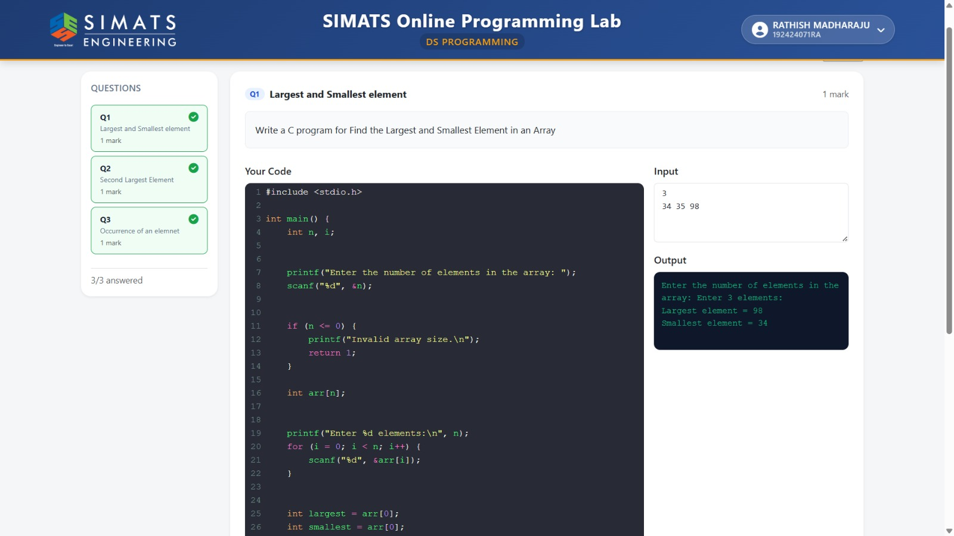
QUESTION 2
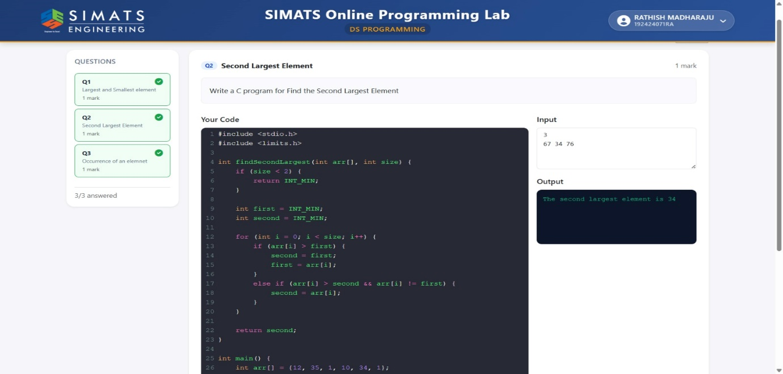
QUESTION 3
